Assignment-3: Java User Input using Scanner Class

Student Details
Name: Krishnan Madhuratnam, Roll No: 25scs1003001176, Class: 2cse22
Question 1: Sum of Two Numbers
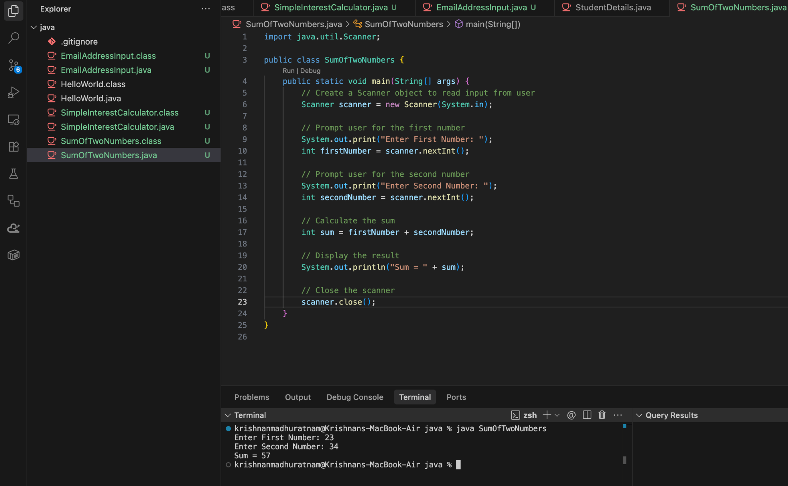

Question 2: Email Address Input
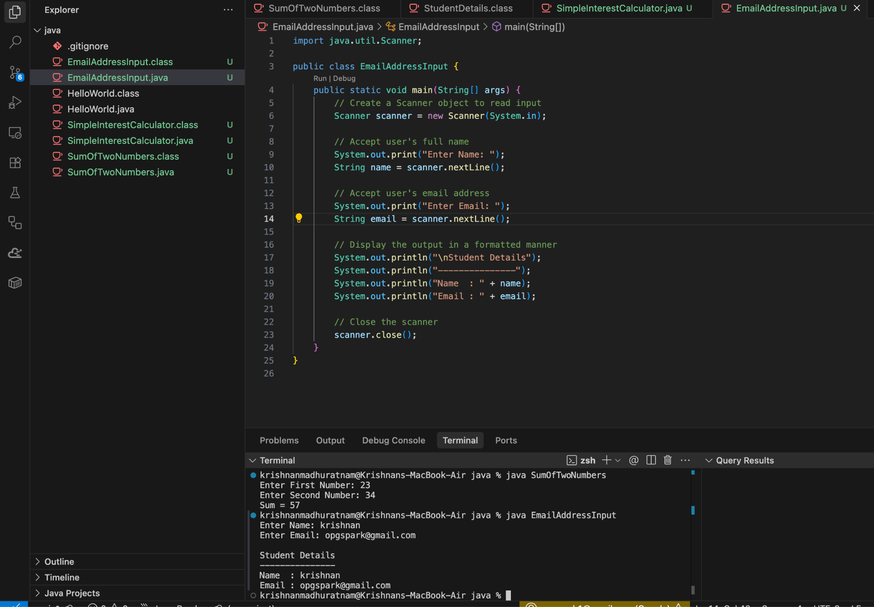

Question 3: Simple Interest Calculator
